- Use Wireshark to capture DHCP Discover, Offer, Request, and Acknowledge messages and explain the process.

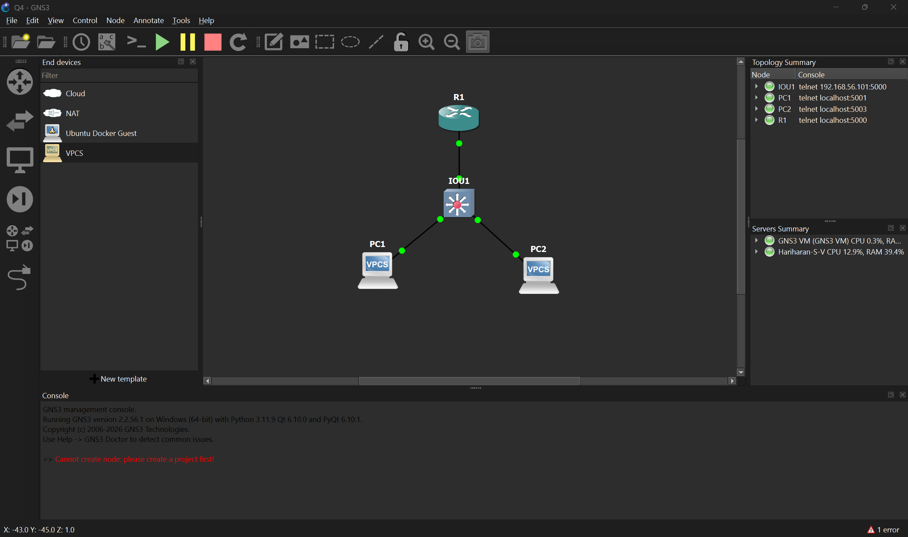
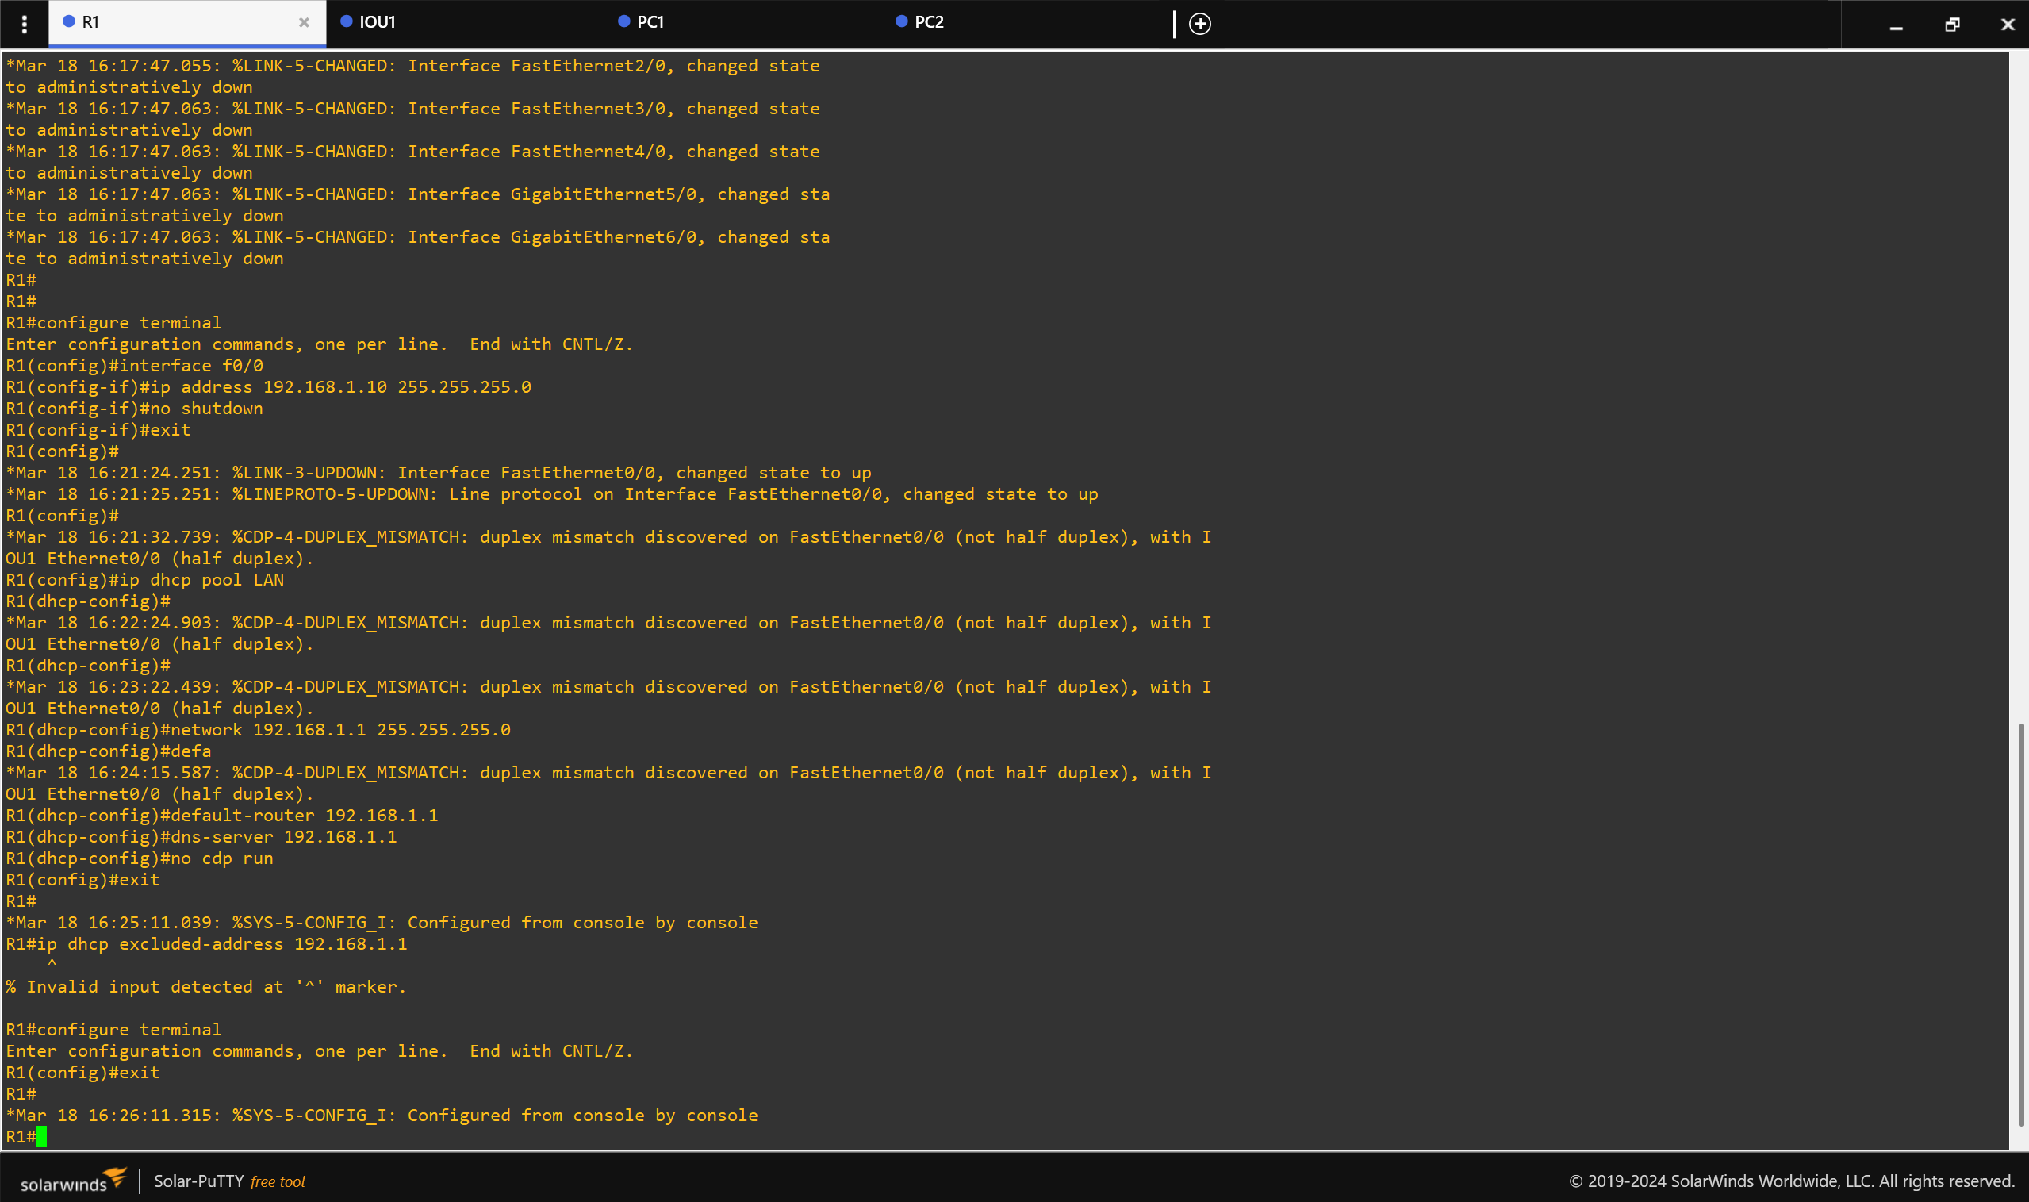
- This to set the router as the DHCP server.
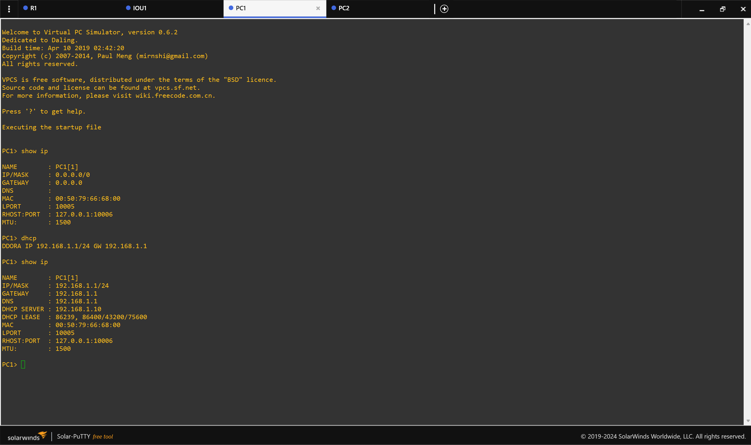
- PC1 communicates with dhcp and requests the ip.
- PC1 sends a broadcast message to find any available DHCP server.
- Discover: In Wireshark, the source IP is 0.0.0.0 (since it doesn't have one yet) and the destination is the broadcast address 255.255.255.255.
- Offer: The capture shows the source 192.168.1.10 (the router) sending an Offer of 192.168.1.1 to the client.
- Request: This is still sent as a broadcast to let other potential DHCP servers know the offer was accepted.
- ACK: The server sends a final ACK packet, finalizing the lease.
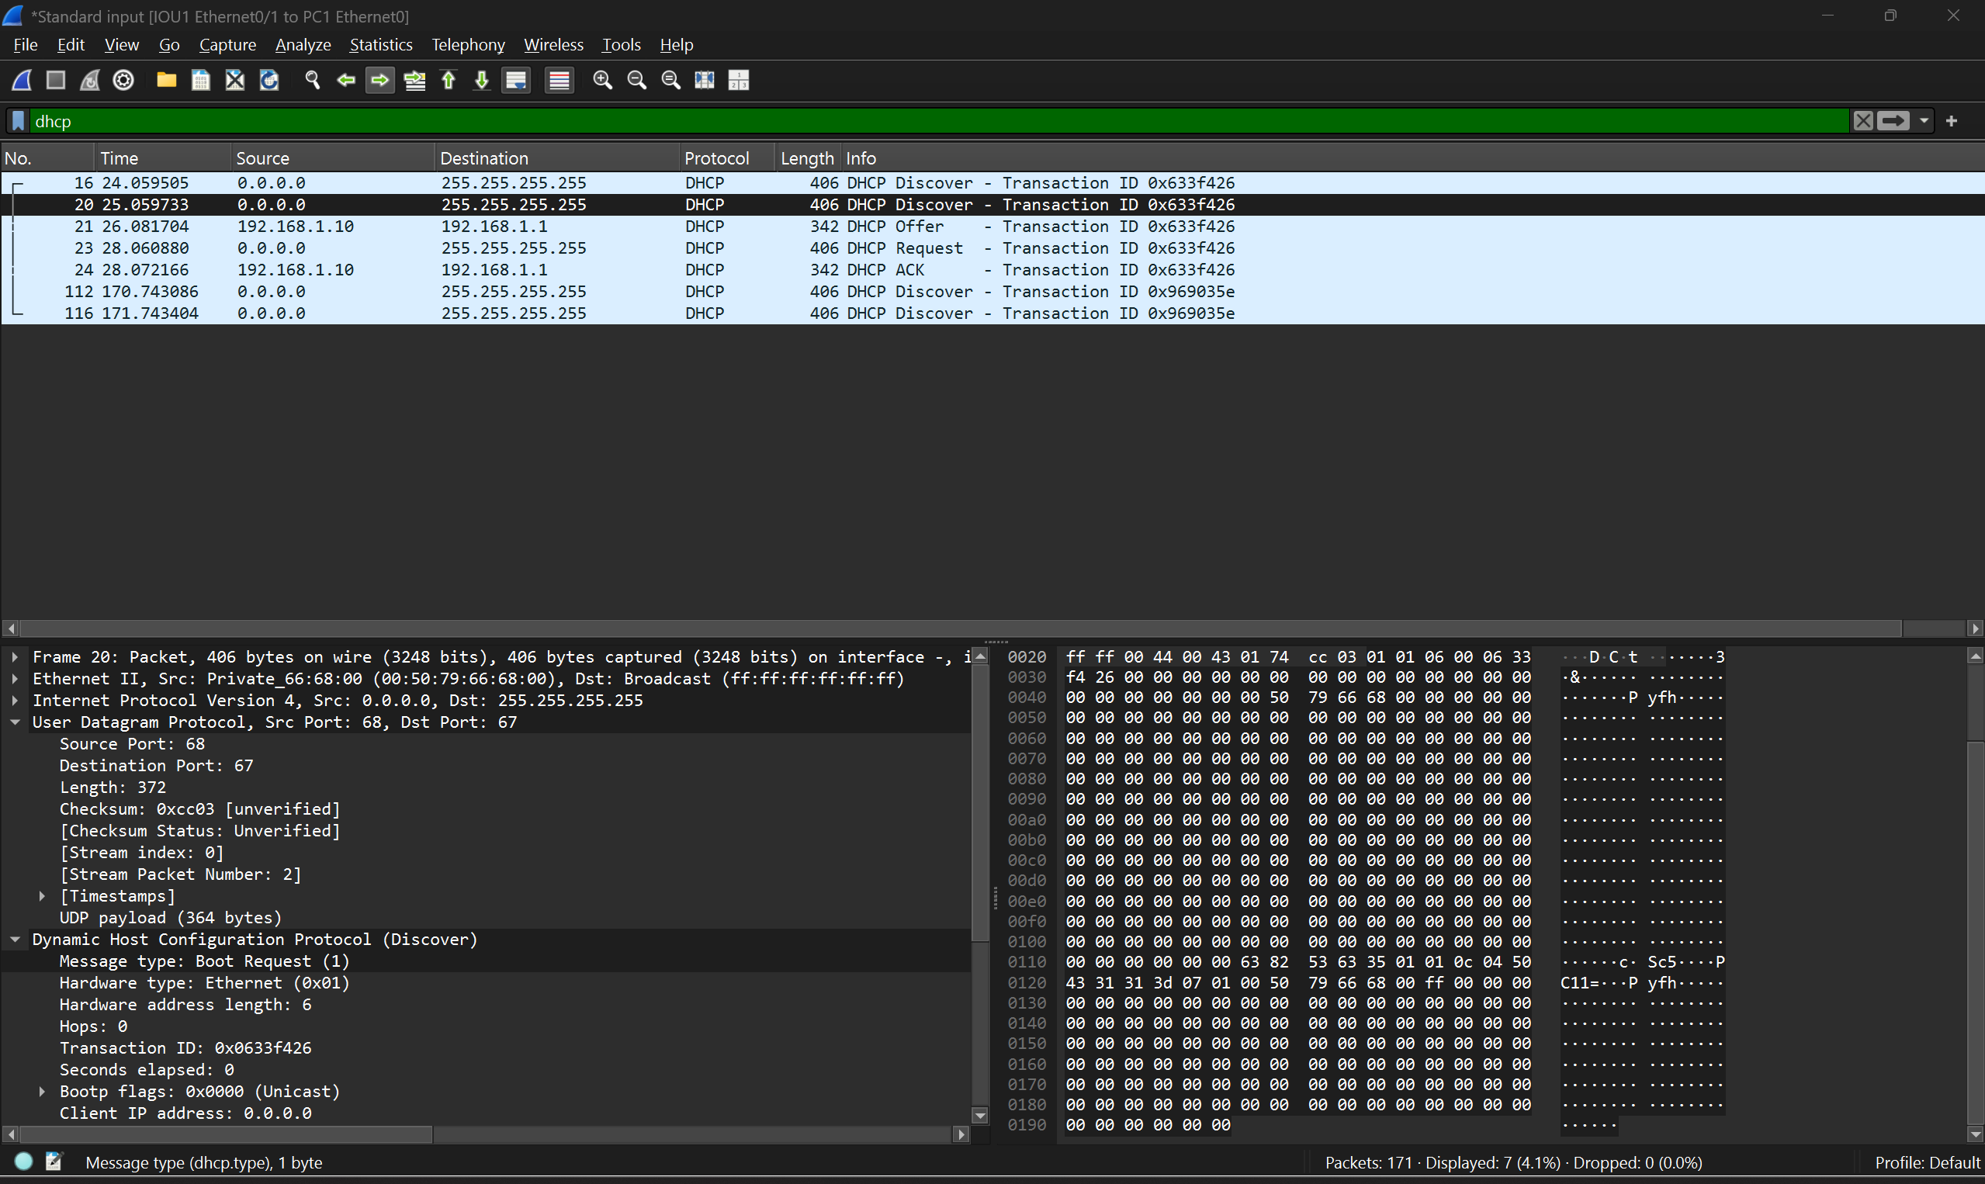
- DORA process in wireshark

